**ESP-WROVER-KIT V4.1 Getting Started Guide**

**Projeto do relógio de cozinha:**

1. Relógio sincronizado com Servidor NTP
   1. OK - Relógio 24hs
   2. OK - Mostrar dia e mês
   3. OK - Mostrar dia da semana
   4. Piscar o RGB led em horas cheias além de bipar das 5:00 às 22:00
2. Timer para ovos
   1. Timer de 7 min
3. Weather Station on-line
   1. Mostrar a Temperatura
   2. Humidade
   3. Pressão Barométrica

ESP-WROVER-KIT features the following integrated components:

* ESP32-WROVER-E module
* LCD screen
* microSD card slot

## Functionality Overview[ℑ](https://docs.espressif.com/projects/esp-idf/en/latest/esp32/hw-reference/esp32/get-started-wrover-kit.html#functionality-overview)

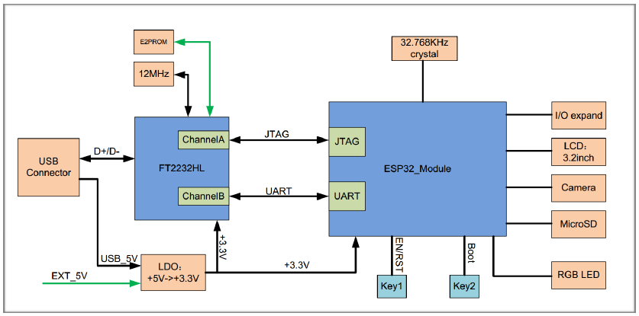

Figura 1 ESP-WROVER-KIT block diagram

## Functional Description[ℑ](https://docs.espressif.com/projects/esp-idf/en/latest/esp32/hw-reference/esp32/get-started-wrover-kit.html#functional-description)

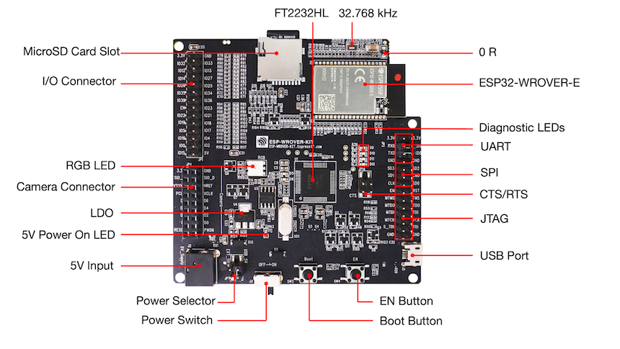

Figura 2 - ESP-WROVER-KIT board layout - front

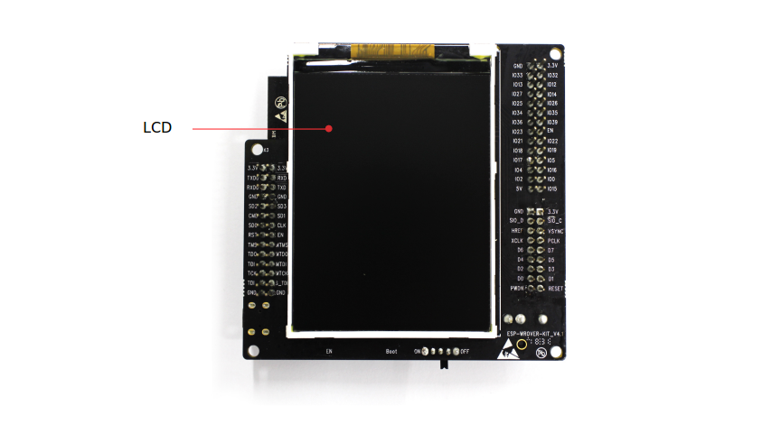

Figura 3 - ESP-WROVER-KIT board layout - back

Buttoms:

|  |  |
| --- | --- |
| EN Button | Reset button. |
| BOOT Button | Download button. Holding down **Boot** and then pressing **EN** initiates Firmware Download mode for downloading firmware through the serial port. |

Other:

|  |  |
| --- | --- |
| Power Selector | Power supply selector interface. The board can be powered either via USB or via the 5V Input interface. Select the power source with a jumper. For more details, see Section [Setup Options](https://docs.espressif.com/projects/esp-idf/en/latest/esp32/hw-reference/esp32/get-started-wrover-kit.html#setup-options), jumper header JP7. |
| 5V Input | 5V power supply interface for a standard coaxial power connector, 5.5 x 2.1 mm, center positive. This interface can be more convenient when the board is operating autonomously (not connected to a computer). |
| 5V Power On LED | This red LED turns on when power is supplied to the board, either from **USB** or **5V Input**. |
| LDO | NCP1117(1A). 5V-to-3.3V LDO. NCP1117 can provide a maximum current of 1A. The LDO on the board has a fixed output voltage, but the user can install an LDO with adjustable output voltage. For details, please refer to [ESP-WROVER-KIT V4.1 schematic](https://dl.espressif.com/dl/schematics/ESP-WROVER-KIT_V4_1.pdf). |
| Camera Connector | Camera interface, a standard OV7670 camera module. |
| RGB LED | Red, green and blue (RGB) light emitting diodes (LEDs), can be controlled by pulse width modulation (PWM). |

## Setup Options

| **Header** | **Jumper Setting** | **Description of Functionality** |
| --- | --- | --- |
| JP7 | jp7-ext_5v | Power ESP-WROVER-KIT via an external power supply |
| JP7 | jp7-usb_5v | Power ESP-WROVER-KIT via USB |

## Allocation of ESP32 Pins

Some of the pins, such as GPIO0 or GPIO2, have multiple functions and some of them are shared among onboard and external peripheral devices. Certain combinations of peripherals cannot work together. For example, it is not possible to do JTAG debugging of an application that is using SD card, because several pins are shared by JTAG and the SD card slot.

In other cases, peripherals can coexist under certain conditions. This is applicable to, for example, LCD screen and SD card that share only a single pin GPIO21. This pin is used to provide D/C (Data/Control) signal for the LCD as well as the Card Detect signal read from the SD card slot. If the card detect functionality is not essential, then it may be disabled by removing R167, so both LCD and SD may operate together.

### Main I/O Connector/JP1[ℑ](https://docs.espressif.com/projects/esp-idf/en/latest/esp32/hw-reference/esp32/get-started-wrover-kit.html#main-i-o-connector-jp1)

The JP1 connector consists of 14x2 male pins whose functions are shown in the middle two "I/O" columns of the table below. The two "Shared With" columns on both sides describe where else on the board a certain GPIO is used.

| **Shared With** | **I/O** | **I/O** | **Shared With** |
| --- | --- | --- | --- |
| n/a | 3.3V | GND | n/a |
| ~~NC/XTAL~~ | ~~IO32~~ | ~~IO33~~ | ~~NC/XTAL~~ |
| JTAG, microSD | IO12 | IO13 | JTAG，microSD |
| JTAG, microSD | IO14 | IO27 | Camera/SW Timer Ovos |
| Camera/Buzzer | IO26 | IO25 | Camera, LCD |
| Camera | IO35 | IO34 | Camera |
| Camera | IO39 | IO36 | Camera |
| JTAG | EN | IO23 | Camera, LCD |
| Camera, LCD | IO22 | IO21 | Camera, LCD, microSD |
| Camera, LCD | IO19 | IO18 | Camera, LCD |
| Camera, LCD | IO5 | IO17 | PSRAM |
| PSRAM | IO16 | IO4 | LED, Camera, microSD |
| Camera, LED, Boot | IO0 | IO2 | LED, microSD |
| JTAG, microSD | IO15 | 5V |  |

### RGB LED[ℑ](https://docs.espressif.com/projects/esp-idf/en/latest/esp32/hw-reference/esp32/get-started-wrover-kit.html#rgb-led)

| **.** | **ESP32 Pin** | **RGB LED** |
| --- | --- | --- |
| 1 | GPIO0 | Red |
| 2 | GPIO2 | Green |
| 3 | GPIO4 | Blue |

### microSD Card[ℑ](https://docs.espressif.com/projects/esp-idf/en/latest/esp32/hw-reference/esp32/get-started-wrover-kit.html#microsd-card)

| **.** | **ESP32 Pin** | **microSD Signal** |
| --- | --- | --- |
| 1 | MTDI/GPIO12 | DATA2 |
| 2 | MTCK/GPIO13 | CD/DATA3 |
| 3 | MTDO/GPIO15 | CMD |
| 4 | MTMS/GPIO14 | CLK |
| 5 | GPIO2 | DATA0 |
| 6 | GPIO4 | DATA1 |
| 7 | GPIO21 | Card Detect |

### LCD/U5[ℑ](https://docs.espressif.com/projects/esp-idf/en/latest/esp32/hw-reference/esp32/get-started-wrover-kit.html#lcd-u5)

| **.** | **ESP32 Pin** | **LCD Signal** |
| --- | --- | --- |
| 1 | GPIO18 | RESET |
| 2 | GPIO19 | SCL |
| 3 | GPIO21 | D/C |
| 4 | GPIO22 | CS |
| 5 | GPIO23 | SDA |
| 6 | GPIO25 | SDO |
| 7 | GPIO5 | Backlight |

Esquema Timer Ovos

